**Module 3: Additional Exercises with Answers**

Download the “Financial Dataset” from the Course Blackboard Site

Course Content> Datasets > Financial.rda

Clear your R workspace using the following command

rm(list = ls())

Load the Financial data into R, using load() command e.g.

load("F:/Kent Teaching/Datasets/Financial.rda")

where F:/Kent Teaching/Datasets/ is a directory at which the downloaded file is located at.

Note that that “/” is used instead of “\” alternatively you could use “//” i.e.

load("F:\\Kent Teaching\\Datasets\\Financial.rda")

As discussed in the class, if you are using a Mac, download the file. Then right click on the file and click on “Get info” then in front of ‘where’ you get the path e.g.

load("/Users/Razavi/Desktop/Financial.rda")

Now you should see a Data frame named Financial in your Global Environment Section

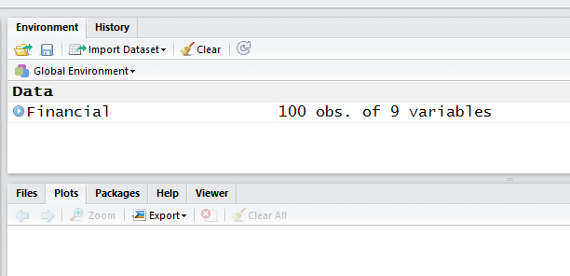

This dataset contains the financial information about 100 companies including their type (type), revenue (rev), assets (assets), return of investment (roe), Earnings Per Share (eps), yield (yield), Dividend Per Share (dps) and finally their Property, Plant and Equipment (ppe).

Answer the following questions:

1. **What are the variable names in the “Financial” dataframe?**

Double click on the data frame to see

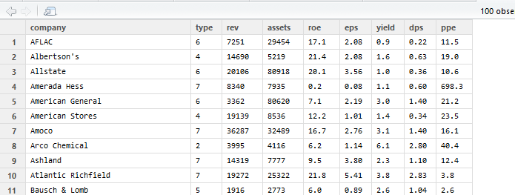

Or print the name of the columns of the data frame using

|  |
| --- |
| > colnames(Financial)  [1] "company" "type" "rev" "assets" "roe" "eps" "yield"  [8] "dps" "ppe" |

1. **What is the mean, median and standard deviation of revenue across all 100 companies?**

> mean(Financial$rev)

[1] 11043.37

> median(Financial$rev)

[1] 6101

> sd(Financial$rev)

[1] 17479.12

1. **What is the highest revenue amongst all companies?**

> max(Financial$rev)

[1] 137242

Alternatively, since we know revenue is the 3rd column, we could write it as

> max(Financial[,3])

[1] 137242

1. **Which company has the highest revenue?**

You can use the command which.max()which returns the index of the highest value e.g. returns 4 if the 4th element is the largest element. Once you know which row contains the highest value you can then print that row:

> which.max(Financial$rev)

[1] 31

And Then:

> Financial[31,]

company type rev assets roe eps yield dps ppe

31 Exxon 7 137242 96064 19.4 3.37 2.8 1.63 17.1

Or alternatively you could do it in one go:

> Financial[which.max(Financial$rev),]

company type rev assets roe eps yield dps ppe

31 Exxon 7 137242 96064 19.4 3.37 2.8 1.63 17.1

1. **Which company has the lowest Return on Investment?**

|  |
| --- |
| > Financial[which.min(Financial$roe),]  company type rev assets roe eps yield dps ppe  4 Amerada Hess 7 8340 7935 0.2 0.08 1.1 0.6 698.3 |
|  |
| |  | | --- | |  |   **6. What are the top 5 companies with highest assets?** |

order() can be used to get the index of the sorted values.

order(Financial$assets)

[1] 72 38 34 65 14 59 77 96 80 30 39 100 97 60 47 35 48 90

[19] 63 52 58 37 99 15 61 40 94 27 84 11 57 98 49 36 44 33

[37] 23 64 76 8 45 54 68 81 62 2 20 88 51 25 86 78 73 89

[55] 91 75 9 4 95 6 12 18 74 50 70 93 56 85 32 92 71 66

[73] 19 13 69 41 21 43 42 67 22 26 10 53 28 1 83 7 16 82

[91] 79 24 55 46 5 3 31 17 29 87

Unless otherwise stated, order always sort values ascendingly i.e. the lowest value is always on top. This means that the company on row 72 has the lowest assets and the one at row 87 has the highest. So the top 5 companies with highest assets are in rows 87,29, 17,31, and 3.

> Financial[c(87,29, 17,31,3),]

company type rev assets roe eps yield dps ppe

87 Travelers 6 37609 386555 14.9 2.54 0.9 0.40 17.0

29 Equitable 6 9666 151438 12.3 2.86 0.5 0.20 13.4

17 CIGNA 6 14935 108199 13.7 4.88 2.0 1.10 11.4

31 Exxon 7 137242 96064 19.4 3.37 2.8 1.63 17.1

1. Allstate 6 20106 80918 20.1 3.56 1.0 0.36 10.6

**7. What is the standard deviation of “roe” values Try to calculate the standard deviation without using the sd() command and by formula, then use the sd() command and compare the results.**

The formula for calculating standard deviation of x, is

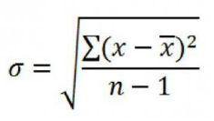

The formula says take the mean of x from each element of x and then square it (i.e. power 2), then sum them up, then divide the result by the number of elements in x mines 1 (that is n-1) and finally calculate the square root of the result. So let’s do this step by step:

Step 1: calculate the mean/average of Financial$roe. We call this roe_average (you can use any other variable name, as long as they are meaningful to you)

roe_average=mean(Financial$roe)

Note that as soon as you execute this line the new variable (value) called roe_average is created in your Global Environment Section

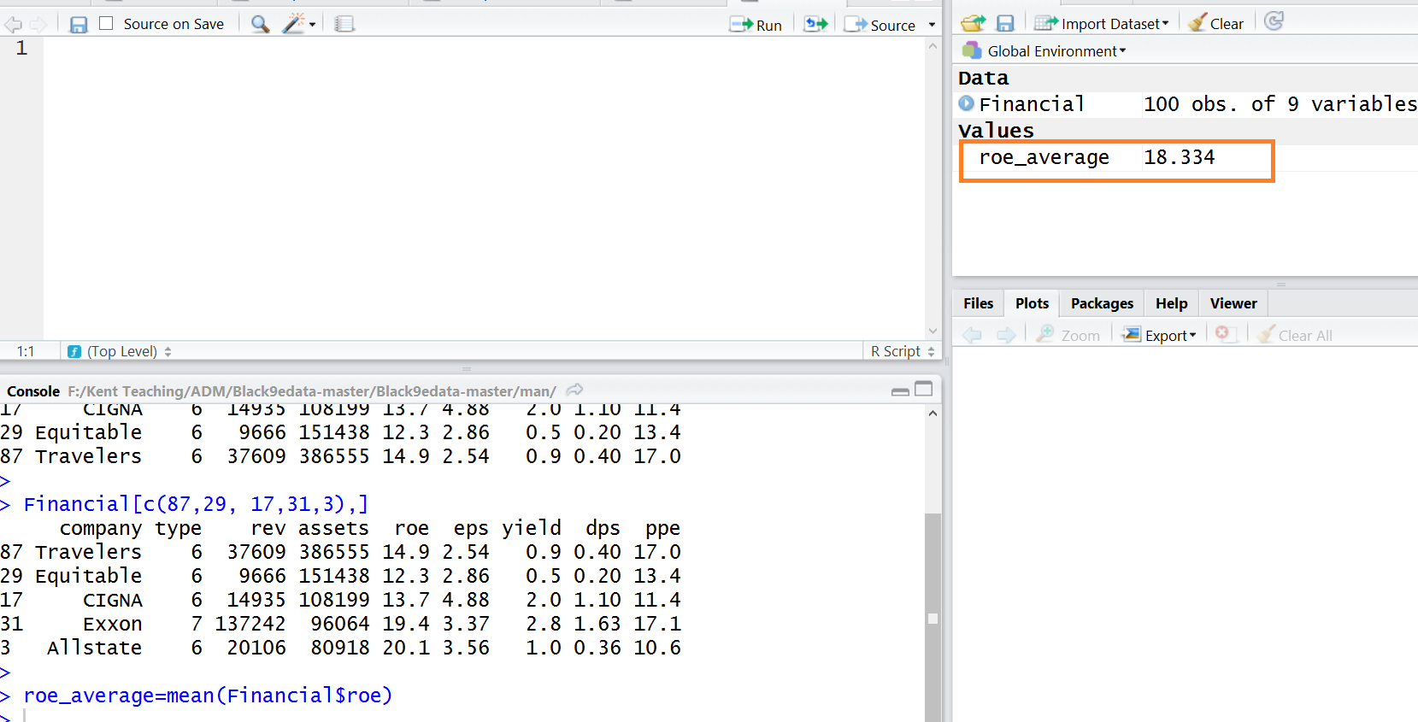

Step 2: Let’s calculate the difference between each of the roe values and their mean as we calculated in step 1. We call this “Diff”.

Diff=Financial$roe-roe_average

Note that once you run this command the new variable, Diff, appears under the Global Environment Section:

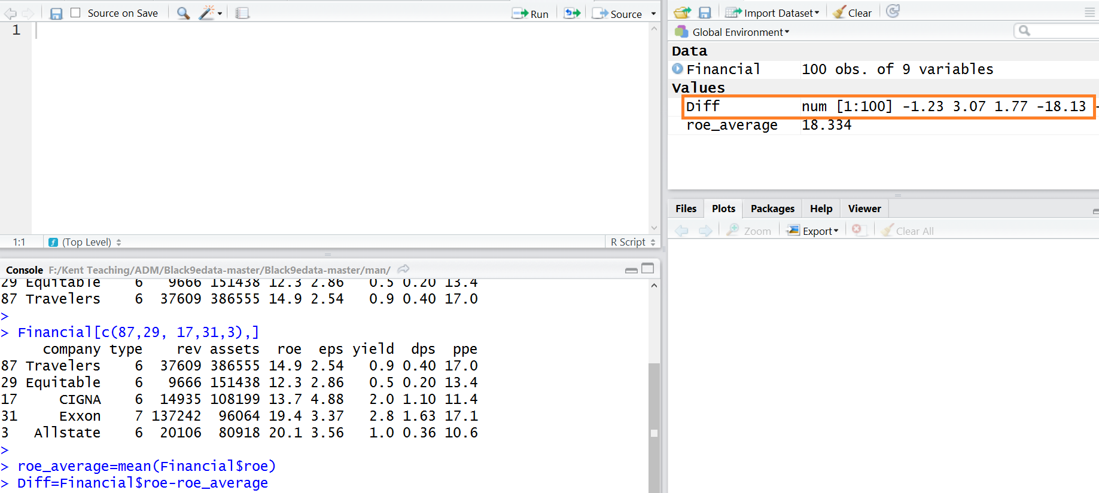

Step 3: Let’s calculate the square of the Diff values and call it “Diff_square”

Diff_square=Diff^2

Or we could write

Diff_square=Diff*Diff

Similarly, new variable Diff_square will be created

Step 4: Lets calculate the sum of the squared differences. We call it “sum_diff_square”.

sum_diff_square=sum(Diff_square);

Step 5: Finally, lets divide the product (i.e. sum_diff_square) by the number of elements (that is 100) mines 1 and calculate the square root of the results to calculate the standard deviation.

sqrt(sum_diff_square /99)

Or

(sum_diff_square /99)^0.5

> sqrt(sum_diff_square /99)

[1] 23.57264

> sd(Financial$roe)

[1] 23.57264

We can see the results are the same.

Tip: Instead of creating intermediate variables such as roe_average, Diff, Diff_square, sum_diff_square etc. we could write everything in one line:

> sqrt(sum((Financial$roe-mean(Financial$roe))^2)/99)

[1] 23.57264

**8. Use the summary() command to get a summary of all variables in the Financial dataframe. By comparing the mean and median, can you say which variables are highly skewed? And in which direction (positive/right skewed versus negative/left skewed). Then use skewness() command to confirm that.**

summary(Financial)

company type rev assets

Length:100 Min. :1.00 Min. : 129 Min. : 194

Class :character 1st Qu.:2.00 1st Qu.: 2259 1st Qu.: 2393

Mode :character Median :4.50 Median : 6101 Median : 5876

Mean :4.23 Mean : 11043 Mean : 18855

3rd Qu.:6.00 3rd Qu.: 12818 3rd Qu.: 16106

Max. :7.00 Max. :137242 Max. :386555

roe eps yield dps

Min. : 0.200 Min. :0.080 Min. :0.100 Min. :0.0200

1st Qu.: 9.475 1st Qu.:1.295 1st Qu.:1.375 1st Qu.:0.4650

Median : 13.950 Median :1.990 Median :2.200 Median :0.9000

Mean : 18.334 Mean :2.247 Mean :2.543 Mean :0.9633

3rd Qu.: 20.150 3rd Qu.:3.027 3rd Qu.:3.100 3rd Qu.:1.2550

Max. :228.000 Max. :7.700 Max. :7.800 Max. :3.2400

ppe

Min. : 2.60

1st Qu.: 13.93

Median : 17.00

Mean : 30.27

3rd Qu.: 24.68

Max. :698.30

Looking at the results above, we can see the mean is much higher than the median for rev, assets, roe, and ppe as such we expect these variables to be highly skewed towards right (i.e., positive skewness). Let us use the skewness() command from the ‘modeest’ library or ‘moments’ library to check the skewness of each variable

> library('modeest')

> skewness(Financial$rev)

[1] 4.384549

attr(,"method")

[1] "moment"

> skewness(Financial$assets)

[1] 6.094588

attr(,"method")

[1] "moment"

> skewness(Financial$roe)

[1] 7.115177

attr(,"method")

[1] "moment"

> skewness(Financial$eps)

[1] 1.054758

attr(,"method")

[1] "moment"

> skewness(Financial$yield)

[1] 1.304713

attr(,"method")

[1] "moment"

> skewness(Financial$dps)

[1] 1.054382

attr(,"method")

[1] "moment"

> skewness(Financial$ppe)

[1] 7.772048

attr(,"method")

[1] "moment"

The above results confirms our predictions as those identified variables have high skewness coefficients.

**9. Calculate the skewness of “assets” without using the skewness() command. Then use the command to compare the results.**

The formula for calculating the skewness of X, is

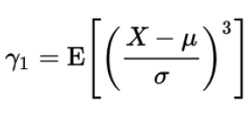

In other words we need to calculate the average of the X, that is Mu and the standard deviation of X that is sigma (in the denominator) , E[] also represents the expected value which is the same as the mean. Let’s do this step by step.

#Step 1: Calculate Mu (the average of X)

Mean_assets=mean(Financial$assets)

#Step 2: Calculate sigma (the standard deviation of X)

Sd_assets=sd(Financial$assets)

#Step 3: Calculate the difference between the values of X and its mean.

Diff= Financial$assets- Mean_assets

#Step 4: Divide by standard deviation

Diff_normalized=Diff/Sd_assets

#Step 5: To power 3 and calculate the mean

mean(Diff_normalized^3)

> #Step 1: Calculate Mu (the average of X)

> Mean_assets=mean(Financial$assets)

> #Step 2: Calculate sigma (the standard deviation of X)

> Sd_assets=sd(Financial$assets)

> #Step 3: Calculate the difference between the values of X and its mean.

> Diff= Financial$assets- Mean_assets

> #Step 4: Divide by standard deviation

> Diff_normalized=Diff/Sd_assets

> #Step 5: To power 3 and calculate the mean

> mean(Diff_normalized^3)

[1] 6.094588

Now let’s use the formula:

> library('modeest')

> skewness(Financial$assets)

[1] 6.094588

attr(,"method")

[1] "moment

Same answer!

**10. Examine the distribution of the “assets” and compare it with “dps”.**

hist(Financial$assets,n=100)

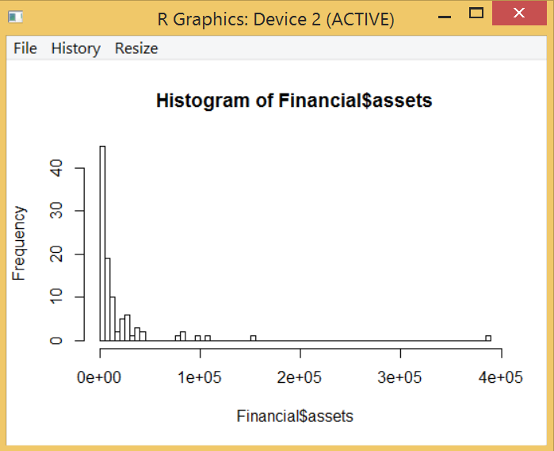

We can see the distribution is highly skewed towards right. We expected this since the skewness coefficient was also high.

hist(Financial$dps,n=100)

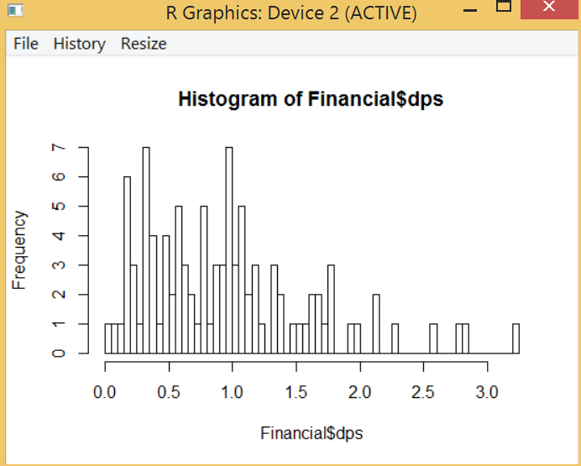

The above distribution is also skewed towards right (hence a positive skewness coefficient) but to a much lesser extent. Skewness was 1.05 compared to 6.09 for assets.

**11. Plot the Boxplot of “Yeild” and “dps” (i.e. columns 7 and 8 of the Financial dataframe). Just by looking at the boxplot, can you say which variable has a larger spread i.e. standard deviation? Confirm this by comparing the standard deviation values.**

boxplot(Financial[,7:8])

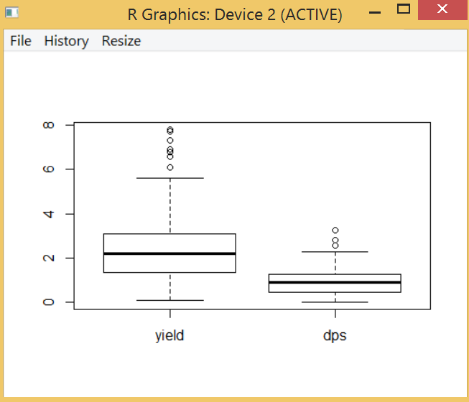

Just by looking at the above, we can see that “Yeild” is much more spread compared to the “dps” values.

> sd(Financial$yield)

[1] 1.737597

> sd(Financial$dps)

[1] 0.6592436

We were right!

**11. Calculate and plot the correlation between all numerical variables in the “Financial” dataframe.**

The numerical variables are in columns 3-9. Lets create a new data frame containing only those variables.

Financial_numerical= Financial[,3:9]

Let’s use the “corrplot” library to plot the correlations:

> corrplot(cor(Financial_numerical))

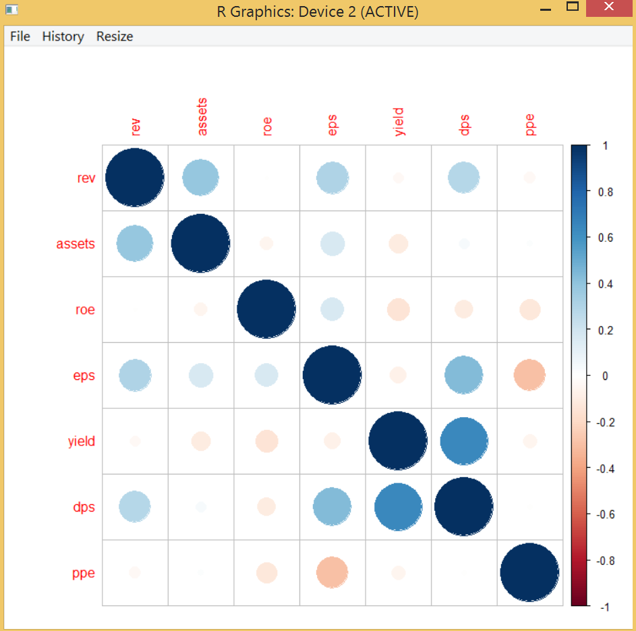

We can see that there is a very strong positive correlation between yield and dps as well as assets and revenue (which makes sense) and

Just by looking at the above, we can see that “Yeild” is much more spread compared to the “dps” values.